[55958- Aman Goswami, Date-11 Dec 2025]
Computer Architecture – CPU, Cores, RAM & Cache
Introduction to Computer Architecture
Computer architecture is the study of how a computer system is designed and how its hardware components work together. It defines the structure, functionality, and communication between parts like the CPU, memory, and input/output devices. The goal of computer architecture is to ensure efficient performance, fast processing, and smooth coordination inside the system.
A computer operates using the Input–Process–Output (IPO) model:
1. Input Unit
Devices such as keyboards, mice, scanners, and sensors send data and instructions to the computer. The input unit converts this information into a form the system can process.
2. Processing Unit (CPU)
The CPU is the brain of the system. It executes instructions, performs calculations, and controls all operations. Using components like the ALU, Control Unit, and registers, the CPU processes incoming data quickly and efficiently. Modern CPUs use advanced techniques like pipelining and multi-core architecture for better performance.
3. Output Unit
After processing, devices like monitors, printers, and speakers present the results to the user in visual, printed, or audio form.
Together, these units create a continuous flow of data—input to processing to output—allowing the computer to perform tasks accurately and efficiently. Computer architecture provides the foundation that enables hardware and software to work together seamlessly, supporting modern needs like multitasking, real-time processing, and high-speed computing.
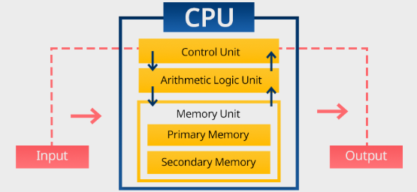
CPU (Central Processing Unit)
The CPU is the main processing component of a computer. It executes instructions, performs calculations, and controls the flow of operations.
The CPU has three main parts:
- ALU (Arithmetic Logic Unit)
Performs mathematical operations (addition, subtraction) and logical decisions (AND, OR, comparisons).
- CU (Control Unit)
Directs the system, tells memory, ALU, and I/O devices what to do.
- Registers
Very small, very fast memory inside the CPU used to hold temporary data.
CPU Cores
Originally, CPUs had a single core.
Modern CPUs have multiple cores:
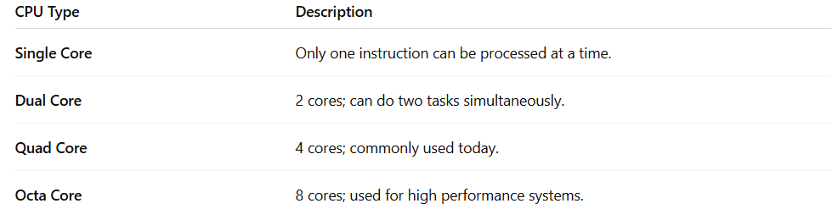
RAM (Random Access Memory)
RAM is the temporary memory where programs and data are stored while the CPU is using them.
Key characteristics of RAM:
- Volatile memory: Data is lost when the computer turns off.
- Much faster than hard disk or SSD.
- Stores:
  - Running applications
  - Operating system files
Types of RAM
- DRAM (Dynamic RAM) – Common in computers.
- SRAM (Static RAM) – Used inside cache memory; faster but expensive.
Cache Memory
Cache is a small, ultra-fast memory located inside or very close to the CPU.
It stores frequently used instructions to reduce the time needed to access data from RAM.
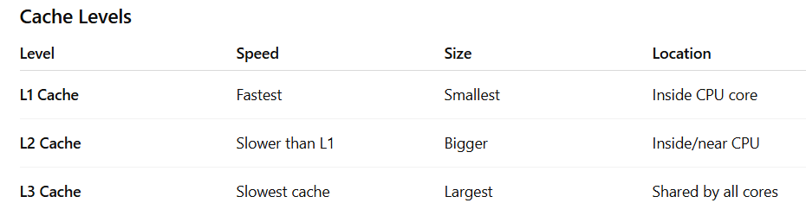

Why cache is important?
- Reduces delay between CPU and RAM
- Improves performance
- Speeds up program execution

